**Assembly instructions document**

This document serves as the assembly instructions for a breadboard adapter PCB compatible the XIAO RP2040 and SAMD21 modules. The resistor dividers and quad op-amp on the adapter board scale the 0 to 3.3 V input range of the XIAO module by 10X (or whatever divider ratio you might choose) and provides a means to offset the range to provide negative input voltages. +/- 16 V differential input is the nominal configuration for 10X attenuation. The board also contains a MCP two channel serial DAC to be used with an RP2040 module to provide two AWG output channels.

These instructions do not teach the reader how to solder through-hole printed circuit boards. We could reproduce a soldering tutorial here but seriously, there are so many good ones out there already, it's probably a waste of time. If the reader has little experience soldering then the following tutorials from SparkFun may be useful:

https://www.sparkfun.com/tutorials/106

https://learn.sparkfun.com/tutorials/how-to-solder-through-hole-soldering

Other such soldering tutorials may be found on line as well.

**Instructions for installing XIAO RP2040 module:**

**Bill of Materials (RP2040):**

|  |  |  |  |
| --- | --- | --- | --- |
| Item | Qty | Reference(s) | Value |
| 1 | 2 | C1, C2 | 1 nF |
| 2 | 2 | J1, J2 | 01x06 Female Header Pin |
| 3 | 2 | U3 | XIAO RP-2040 Module |
| 4 | 1 | J4 | 01x07 Female Header Pin |
| 5 | 4 | R1, R3, R5, R7 | 910k |
| 6 | 8 | R9, R10, R11, R12, R13, R14, R15, R16 | 100k |
| 7 | 2 | R17, R18 | 100 |
| 8 | 4 | R19, R20, R21, R22 | 220 |
| 9 | 4 | R23, R24, R25, R26 | 510 |
| 10 | 2 | R27, R28 | 1k |
| 11 | 1 | RV1 | 500 |
| 12 | 1 | U1 | LM324 or LM2902 or MCP6004 |
| 13 | 1 | U2 | MCP4922 (DAC) |

Amplifier U1 uses the standard pinout for quad op-amps and any version that can operate from a 4.7 V (USB voltage minus a diode drop) power supply could potentially be used. Rail-Rail input / output capable amplifiers are best suited for this application. Low cost quad devices such as the LM324 or similar can be used because it supports an input common mode voltage that includes ground. Depending on the particular version / vendor of the LM324, pull down resistors R23 – R26 (510 ohm) may or may not be needed. If a true Rail-Rail amplifier such as the MCP6004 is used resistors R23, R24, R25, R26 can be omitted.

It is best to start assembly with the components with the lowest profile, like the resistors. Place all the resistors of the same value at a time and solder them in place before moving on to the next value. Locate where each resistor goes by the reference designator (R1, R3 etc.) on the silk screen (Note: figure 2.) A small piece of masking tape can be used to hold the resistors tight to the top surface of the board while soldering the leads on the bottom of the board. Once all the resistors are installed move on to the next highest profile components like the DIP op-amp U1. Be sure to note the notch in the silk screen outline for the op-amp and Pin 1 designated by the square solder pad. Be sure to insert the op-amp properly aligned with Pin 1. Same for installing the MCP4922 DAC U2.

The XIAO RP-2040 board is installed using the U3 location with the USB C connector facing outward toward the PCB board edge (Note: figure 3 assembled PCB).

The female header sockets are the tallest and should be installed last.

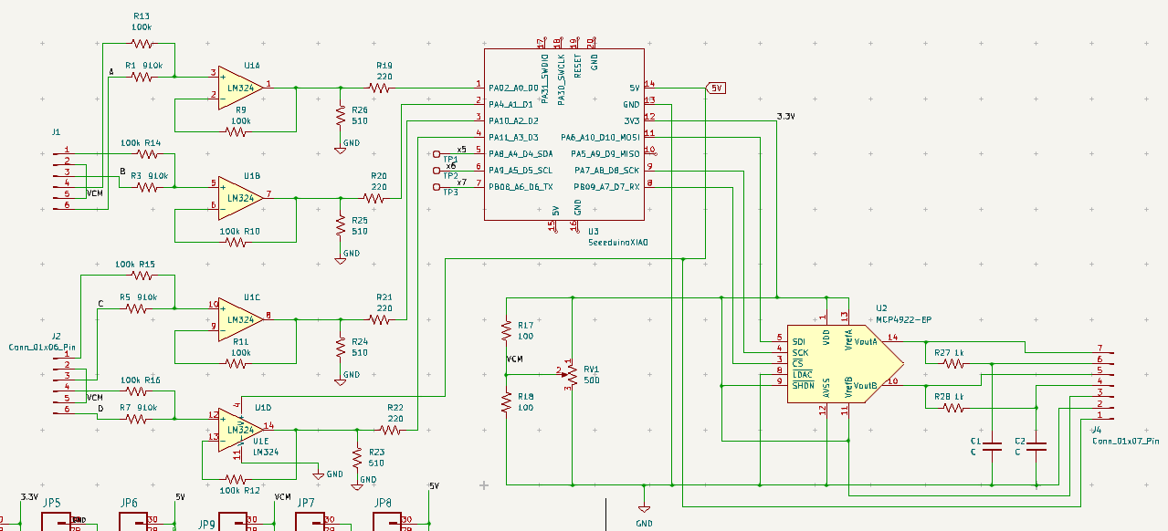

Figure 1 XIAO RP-2040 breadboard adapter schematic

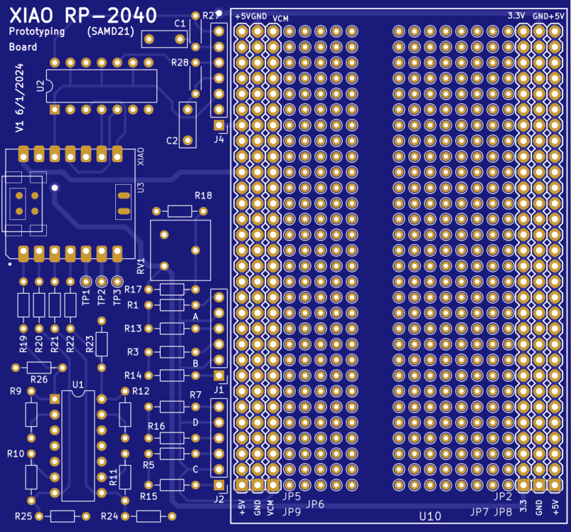

Figure 2 XIAO RP-2040 breadboard adapter PCB Top - silk screen

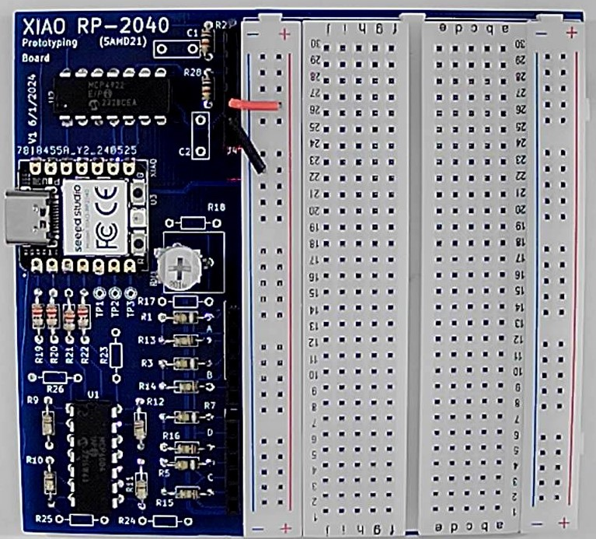

Figure 3 XIAO RP-2040 breadboard adapter PCB assembled (MCP6004).

The two digital PWM outputs are available on TP2 and TP3.

**Instructions for installing XIAO SAMD21 module:**

**Bill of Materials (SAMD21):**

|  |  |  |  |
| --- | --- | --- | --- |
| Item | Qty | Reference(s) | Value |
| 1 | 2 | C1, C2 | Optional for PWM LPF |
| 2 | 2 | J1, J2 | 01x06 Female Header Pin |
| 3 | 2 | U3 | XIAO SAMD21 Module |
| 4 | 1 | J4 | 01x07 Female Header Pin |
| 5 | 4 | R1, R3, R5, R7 | 910k |
| 6 | 8 | R9, R10, R11, R12, R13, R14, R15, R16 | 100k |
| 7 | 2 | R17, R18 | 100 |
| 8 | 4 | R19, R20, R21, R22 | 220 |
| 9 | 4 | R23, R24, R25, R26 | 510 |
| 10 | 2 | R27, R28 | Optional for PWM LPF |
| 11 | 1 | RV1 | 500 |
| 12 | 1 | U1 | LM324 or LM2902 or MCP6004 |

The XIAO RP2040 and XIAO SAMD21 share a very similar pinout as we see in figure 4. This PCB can also be configured / adapted for use with the XIAO SAMD21 module. The main difference between the RP2040 module and the SAMD21 module is that on the SAMD21 module Pin A0 becomes the DAC output. The four ADC pins on the RP2040 are on pins A0 – A3. The four ADC pins on the SAMD1 move over one pin and are on A1 – A4. This shift of the ADC input pins is outlined in figure 4.

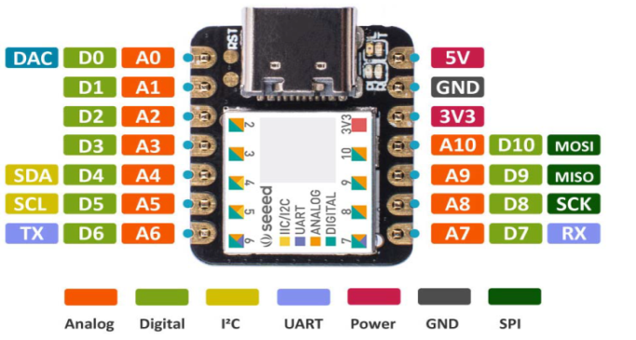

AWG Output

Scope CH A

Scope CH B

Scope CH C

Scope CH D

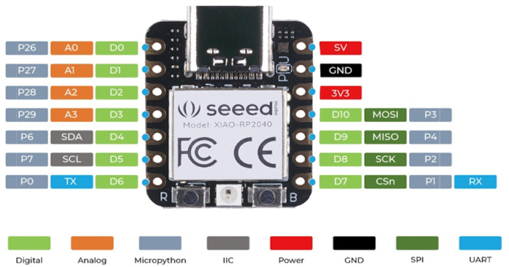

XIAO SAMD21

XIAO RP2040

Scope CH A

Scope CH B

Scope CH C

Scope CH D

Figure 4, SAMD21 vs RP2040 pinout.

To accommodate this shift, TP1 (which is connected to A4) is used. Resistor R22 is inserted diagonally between TP1 and the end of the R22 location closest to the R22 silk screen text. Similarly, resistors R19, R20, and R21 are inserted diagonally as shown in the figure 5 close up photo of an assembled SAMD21 board.

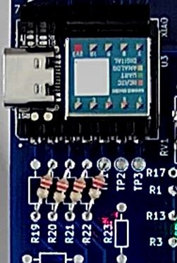

Figure 5, Insertion of R19 – R22 close up.

With the exception of omitting U2, the MCP4922 serial DAC, the rest of the assembly of the boards is the same as the RP2040 version. The DAC output can be accessed directly on pin A0 or the unused end of the R19 location. A jumper wire could be added from the unused end of R19 to either pin 14 or pin 10 of U2 or the end of either R27 or R28. The DAC output would then appear on one of the J4 pins. Alternatively, as shown in figure 6, 7 pin female headers can be stacked in the holes of the XIAO module to access all of the modules pins.

The PWM digital outputs are on pins D9 and D10. These PWM outputs can be optionally connected to the R27, C1 or R28, C2 low pass filters on connector J4.

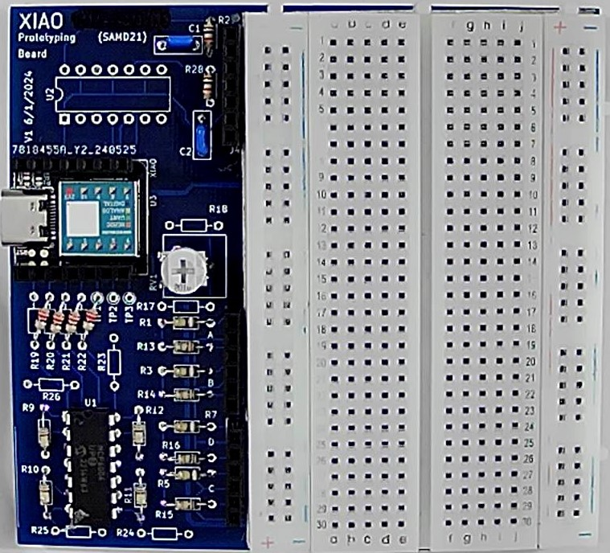

Figure 6 XIAO SAMD21 breadboard adapter PCB assembled (MCP6004).

The ALICE software as configured by the XIAO_4a_1w_pwm_Interface_Level.py file supports access to the raw analog input pins A5, A6, A7 and A8. These additional 4 input pins can optionally be connected to the now unused (because U2 has been omitted) pins on J4 using jumper wires to more easily access these pins (assuming they are not being used for the PWM outputs).

**Resistor Color Code:**

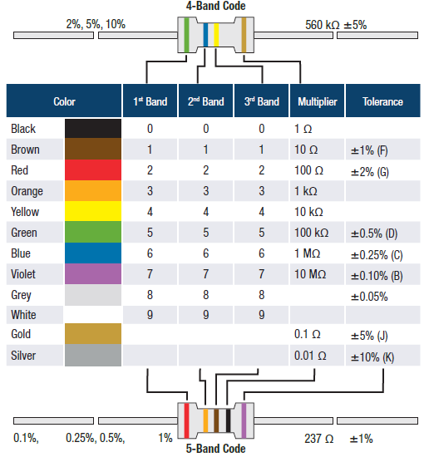

**Soldering Hints:**

1. Insert the component tight against the PCB surface and carefully solder the leads.

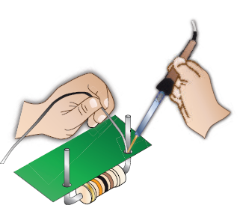

2. Make sure the solder joints completely surround the component lead and are cone-shaped and shiny.

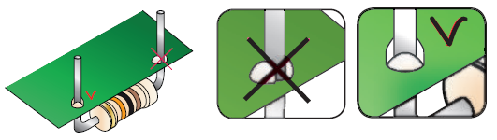

3. Trim excess leads as close as possible to the solder joint.

